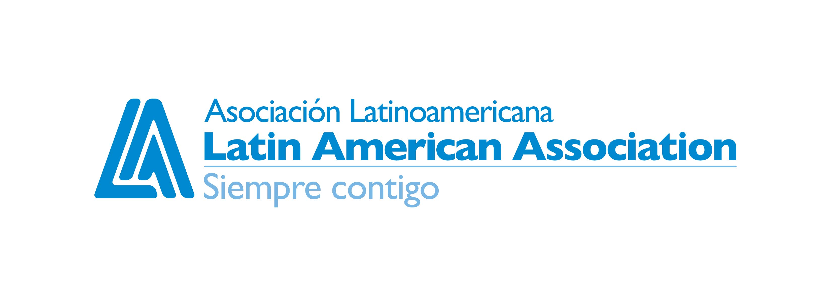
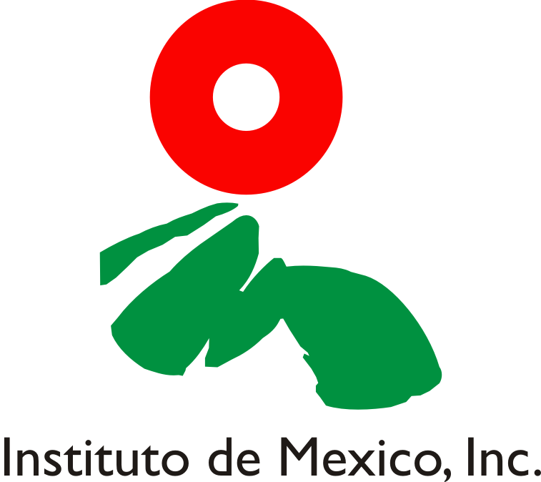
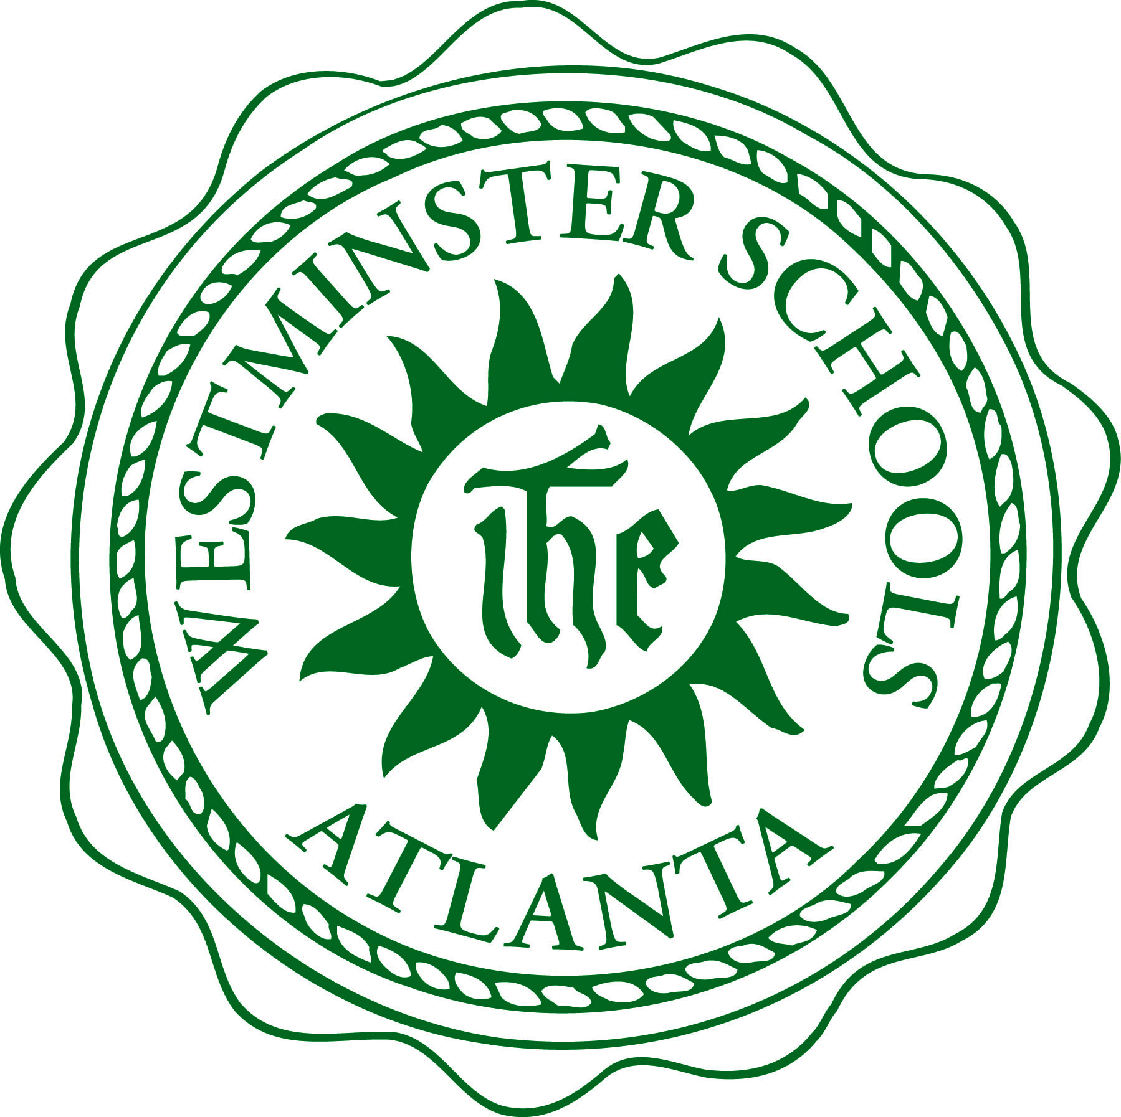
MEDIA ALERT
TO: ALL MEDIA
DATE: June 22, 2009

FROM: Sarah Marske, LAA Communications and Public Relations Manager

Ph: (404) 471-1892 Email: smarske@thelaa.org

Artist Ernesto Cuevas to Paint Mural with Participants in Latin American Association’s ¡Inspira! Summer Camp

Activity is in Partnership with the Westminster Schools, the Institute of Mexico, and the Consul General of Mexico

WHAT: Participants in the Latin American Association’s (LAA) ¡Inspira! Summer Camp, along with Westminster High School students, will work together to paint a mural that portrays a theme of the students’ choice. The project will be directed by artist Ernesto Cuevas and will teach the children about art, history and culture.

The mural will be unveiled Thursday, June 25 at 1:30 p.m. on the Westminster School campus.

WHEN:
- Tuesday, June 23: Mural painting, 8 a.m. – 2 p.m.
- Wednesday, June 24: Mural painting, 8 a.m. – 2 p.m.
- Thursday, June 25: Mural unveiling, 1:30 p.m.

WHERE: Westminster Schools: 1424 West Paces Ferry Rd. N.W. Atlanta, GA 30327.

WHO: A descendant of Mexico, Ernesto Cuevas founded the RedCielo organization, a program that focuses on art education for youth through mural projects. Ernesto’s art is displayed at Georgia State University, the University of Georgia, George Washington University, and Dartmouth University. His work has also been displayed at the Coca-Cola Company, Hispanic Heritage Celebrations, Café Tu Tu Tango, and Chateau Elan Winery.

Students painting the mural participate in the LAA’s ¡Inspira! Summer Camp, a program designed to increase academic performance and provide recreational and enrichment activities in the areas of science and math.
The Instituto y Consulado de Mexico is a nonprofit organization dedicated to the development of the Mexican community in Atlanta and seeks to promote and spread Mexican history and culture.

CONTACT: Eliezer Velez, 404-638-0393

###
About The Latin American Association:
The Latin American Association helps Latino families achieve their aspirations for their academic, social and economic development. We accomplish this through direct programs and integrated community partnerships that focus on youth academic achievement, education and prevention, and services to families with urgent needs. The LAA offers employment, immigration and translation services, as well as programs for youth, computer classes, parenting classes, and English and Spanish language classes. Visit www.thelaa.org for more information.

